Install Java

Folder where java executable saved:

\\mnepapp81-d\xPression\EPS_Team\xPression 4.7 Migration\Install

jdk-11.0.4_windows-x64_bin

installed on the server: DC2APP1081D

D:\Java\jdk-11.0.4

Set environmental variables JAVA_HOME D:\Java\jdk-11.0.4

JBOSS_HOME D:\Jboss

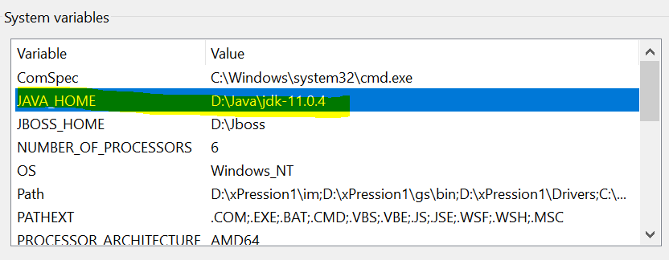

Create a folder on the server:

D\xPression1

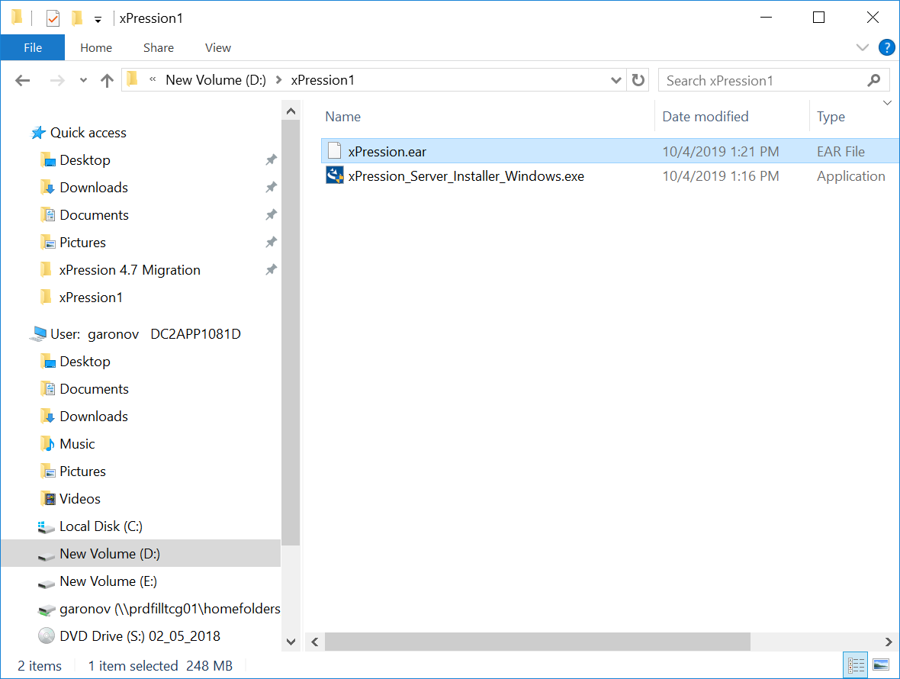

Copy 2 files to the folder: xPression.ear and xPression_Server_Installer_Windows.exe

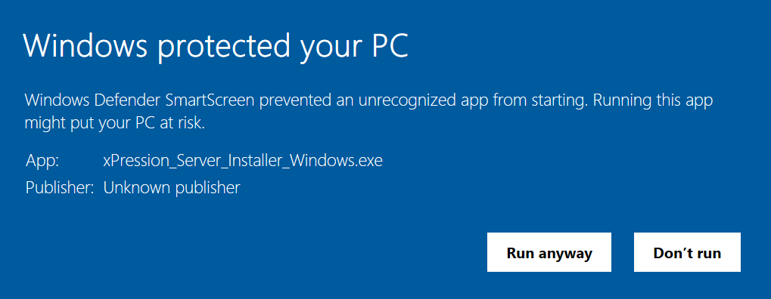

Click “Run anyway”

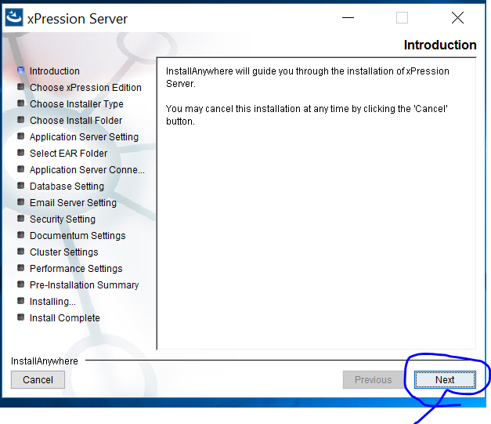

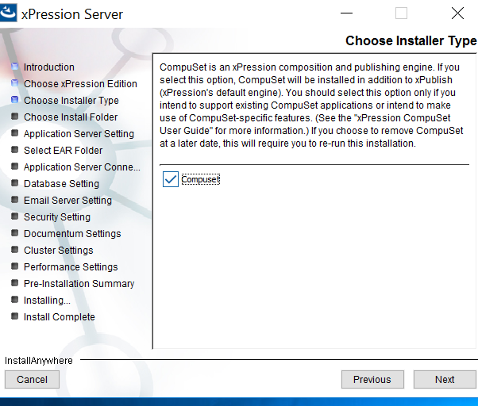

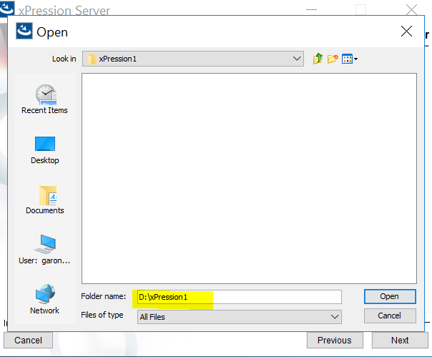

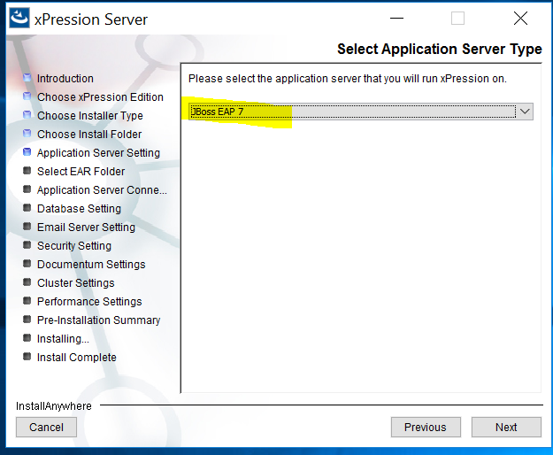

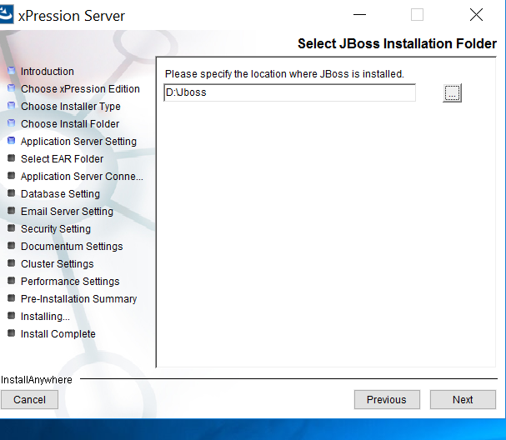

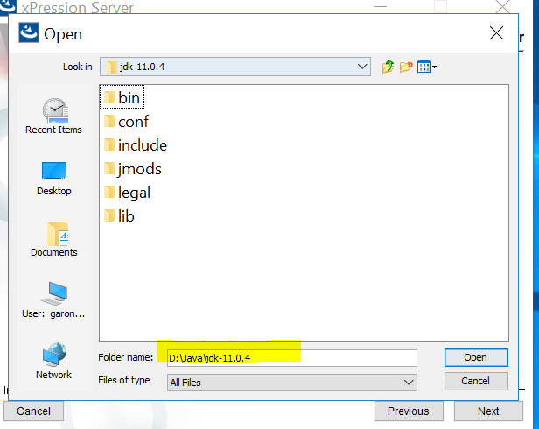

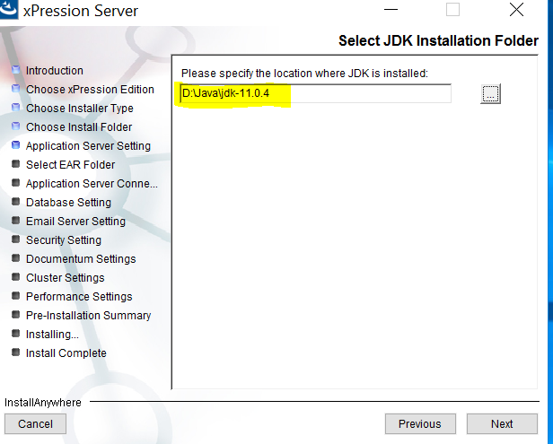

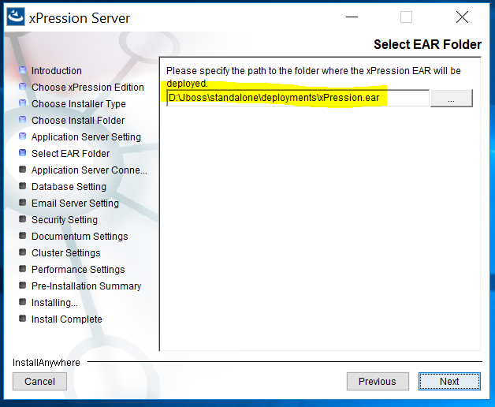

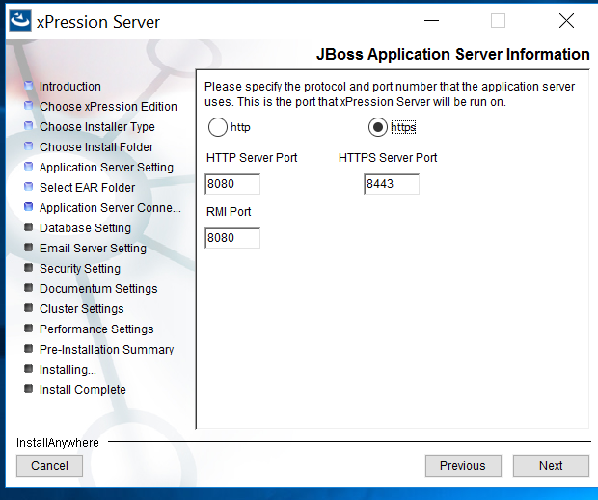

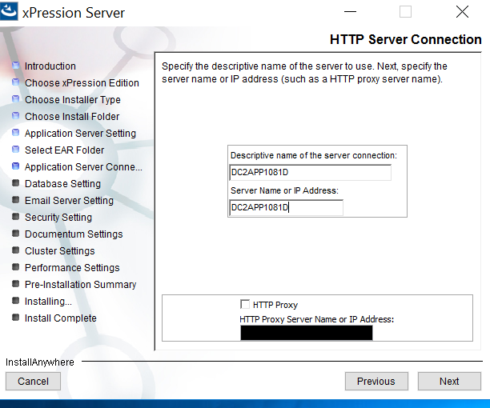

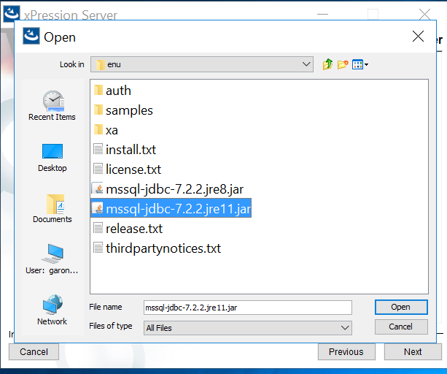

Path for sql server driver

D:\sqljdbc_7.2\enu\mssql-jdbc-7.2.2.jre11.jar

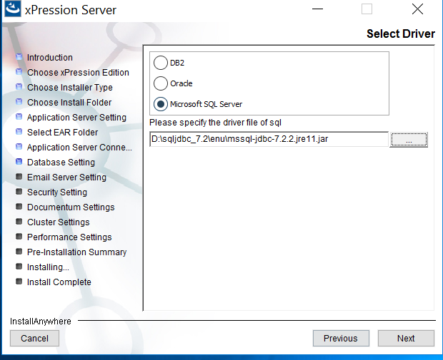

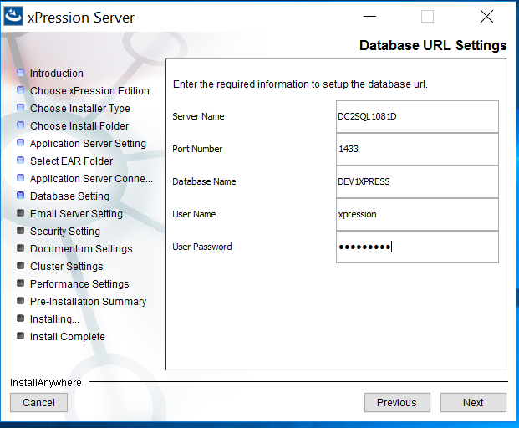

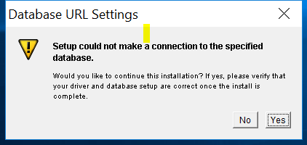

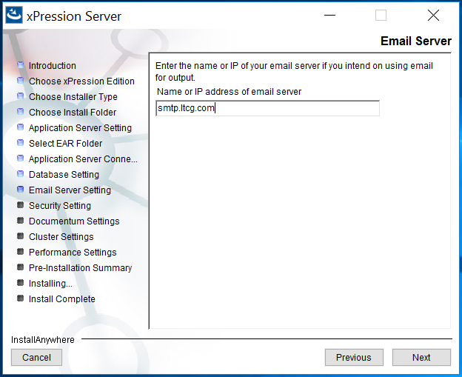

Choose **LDAP** authentication.

Enter in **test** for the password and click **Next**. (LDAP will be configured after the installation.

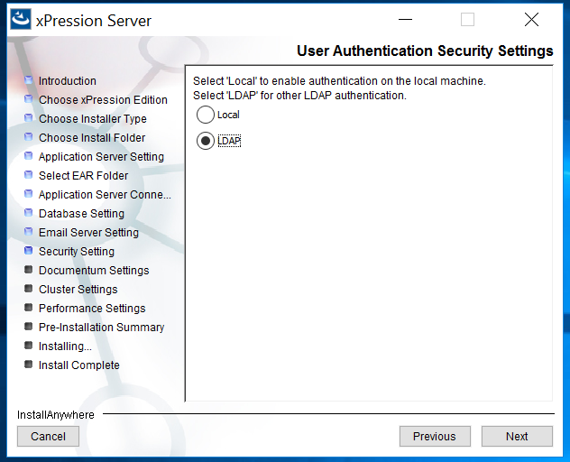

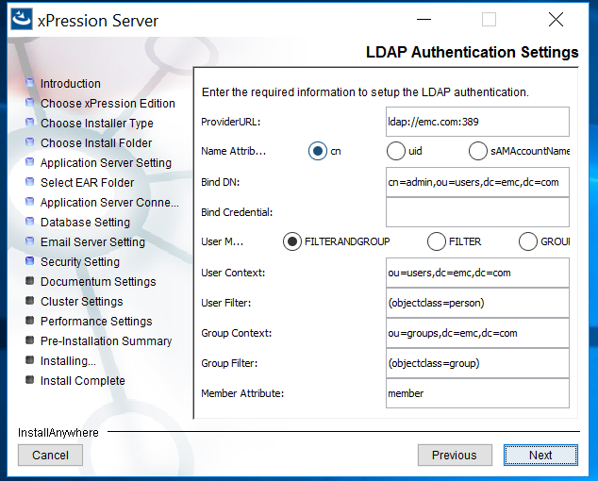

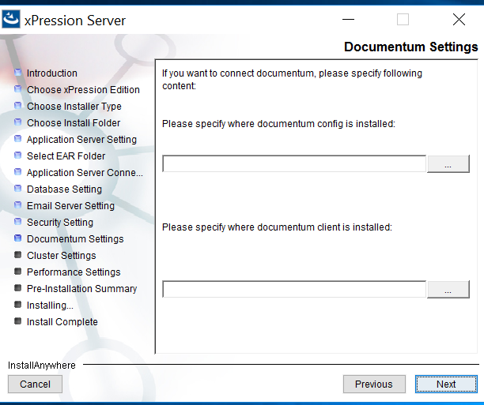

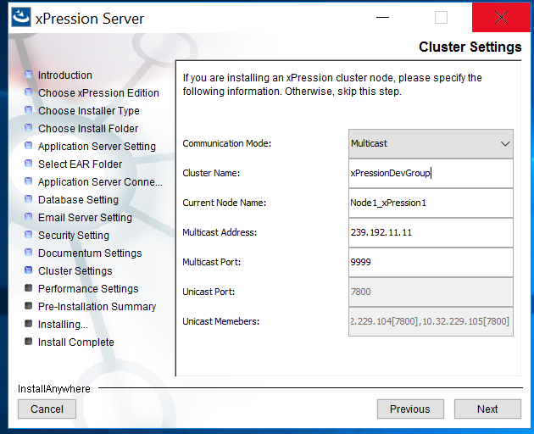

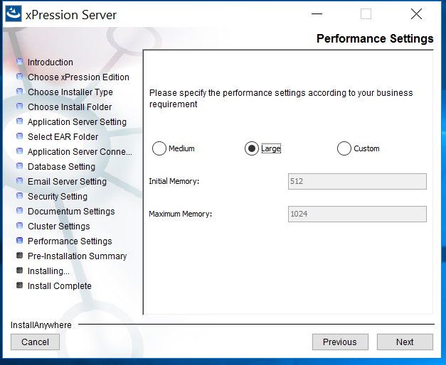

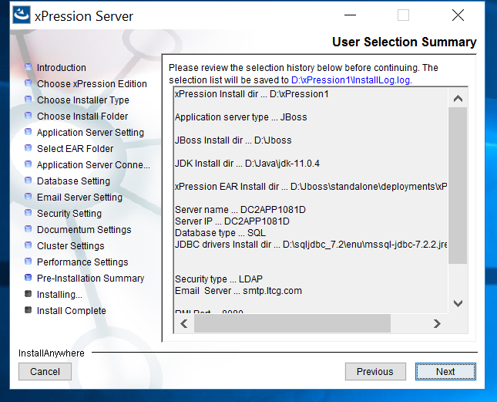

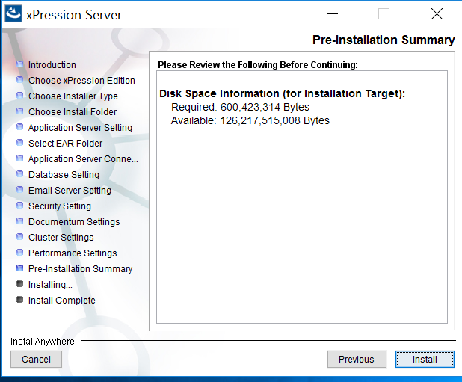

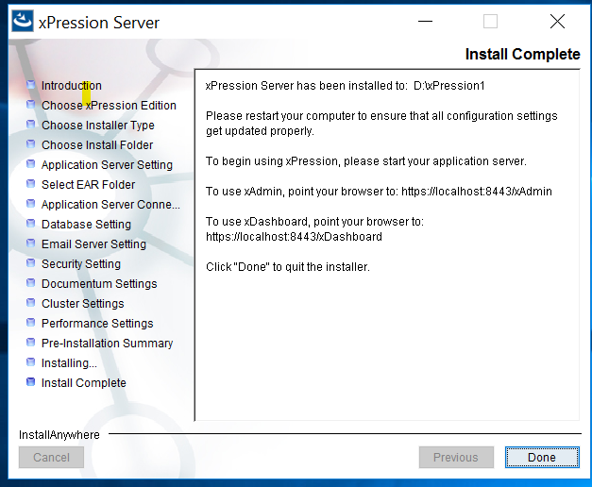

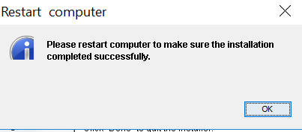

**Running as a windows service**

* Extract jbcs-jsvc-1.1.0-win6-x86_64 to d:\jbcs-jsvc-1.1.  You should now have a path d:\jbcs-jsvc-1.1\bin. Verify this exists.
* In the Jboss bin directory, Create a copy of service.bat, call it xPressionService.bat.
* In xPressionService.bat, Update the path to jbcs-jsvc in the file to point to the correct folder.
  + I just replaced all occurrences of jbcs-jsvc-1.0 with jbcs-jsvc-1.1
* Open a command prompt as an administrator
* Navigate to the Jboss bin folder in command prompt
* Run the following command

xPressionService.bat install /startup /name JBoss_xPression1_Server /desc JBoss_xPression1_Server /config xpression-standalone.xml /loglevel INFO

* Run services.msc
* Verify the Jboss_xPression1_Server service exists
* Update the username and password for the service - see Brent for credentials.  Credentials are different between dev, test, and production. **DO NOT USE THE SAME CREDENTIALS IN EACH ENVIRONMENT**
* Start the service
* Verify the xPression server is running without issue

Username is [SVC-EPS-APP-DEV@corporate.ltcg.com](mailto:SVC-EPS-APP-DEV@corporate.ltcg.com)

Update files:

D:\Jboss\bin\standalone.conf.bat

D:\xPression1

BatchRunner.properties

BatchRunner.bat

**BatchRunner.bat** we set it to -Xms1024M -Xmx4096M

From Java_Option=-server -Xms512M -Xmx1024M

To Java_Option=-server -Xms8G -Xmx8G

Copy files from  D:\xPression1\CustomerData  from 4.5 to 4.7?

From mnepapp81-d to DC2APP1081D

Copy files from \\mnepapp81-d\xPression1\image

To DC2APP1081D

D:\xPression1\image

|  |  |  |
| --- | --- | --- |
| **Filename** | **Comparison result** | **Changes needed to 4.7 file** |
| Bats | Left only: \\mnepapp81-p\xPression1 | Copy from respective 4.5 dev, test, or prod server |
| CustomerData |  | Copy from respective 4.5 dev, test, or prod server, except servers.xml |
| EPSUtil | Left only: \\mnepapp81-p\xPression1 | Copy from respective 4.5 dev, test, or prod server |
| Publish |  | Copy from respective 4.5 dev, test, or prod server |
| xBatchlog | Left only: \\mnepapp81-p\xPression1 | Copy from respective 4.5 dev, test, or prod server |
| BatchRunner.bat | Text files are different | -Xms1024M -Xmx4096M |
| BatchRunner.properties | Text files are different | ListenerFactoryImpClass = com.ltcg.userexit.LtcgLifeCycleListenerFactory  Java_Option=-server -Xms1024M -Xmx4096M |
| customerdata.properties | Text files are different | LTrim=true   RTrim=true |
| defaultMetaDataFormat.xml | Text files are different | Copy from respective 4.5 dev, test, or prod server |
| ldapcfg.properties | Text files are different | Copy from respective 4.5 dev, test, or prod server |
| LogConfiguration | Text files are different | Change to use DailyRollingFileAppender |

1. Edit d:\jboss\standalone\configuration\xpression-standalone.xml
2. Remove this section from the file:

                    <security>

  <user-name>xpression</user-name>

  <password>tpwpCXih</password>

                    </security>

1. Change the <connection-url>
   1. Add integratedSecurity=true;
   2. For example, for the dev server, it should look like this:  <connection-url>jdbc:sqlserver://DC2SQL1081D:1433;selectMethod=cursor;databaseName=DEV1XPRESS;integratedSecurity=true;</connection-url>
      1. This connection-url will be different between dev, test, and prod, as there will be difference sqlserver and databaseName values.
2. Copy D:\sqljdbc_7.2\enu\auth\x64\sqljdbc_auth.dll to the following folders:
   1. d:\Java\jdk-11.0.4\bin
   2. d:\Java\jdk-11.0.4\lib
3. Restart the xPression service
4. Verify no errors in jboss log
5. Verify that you can still get into xAdmin